Arrays

1.Write a program to sum up all the elements of an array.

import java.util.Scanner;

public class Arrayaddition

{

public static void main (String args[])

{

System.out.println("Enter the elements");

Scanner sc=new Scanner(System.in);

int a[]=new int[10];

int sum=0;

for(int i=0;i<10;i++)

{

a[i]=sc.nextInt();

//sum=sum+i;//

}

for(int i : a)

{sum=sum+i;}

System.out.println("Sum of array elements is: "+sum);

}}

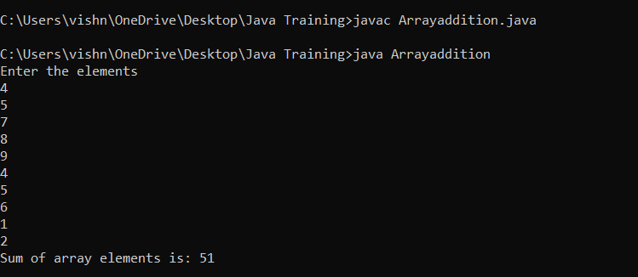

2. Write a program to add two matrices.

import java.util.Scanner;

public class MatrixAddition

{

public static void main (String args[])

{

Scanner sc=new Scanner(System.in);

System.out.println("Enter the rows and columns ");

int m=sc.nextInt();

int n=sc.nextInt();

int a[][]=new int[m][n];

System.out.println("Enter the Matrix 1 ");

for(int i=0;i<m;i++)

{for(int j=0;j<n;j++)

{

a[i][j]=sc.nextInt();}}

int b[][]=new int[m][n];

System.out.println("Enter the Matrix 2 ");

for(int i=0;i<m;i++)

{for(int j=0;j<n;j++)

{

b[i][j]=sc.nextInt();}}

int c[][]=new int[m][n];

for(int i=0;i<m;i++)

{for(int j=0;j<n;j++)

c[i][j]=a[i][j]+b[i][j];

}

for(int i=0;i<m;i++)

{for(int j=0;j<n;j++)

System.out.print(c[i][j] + " ");

System.out.println();

}

}}

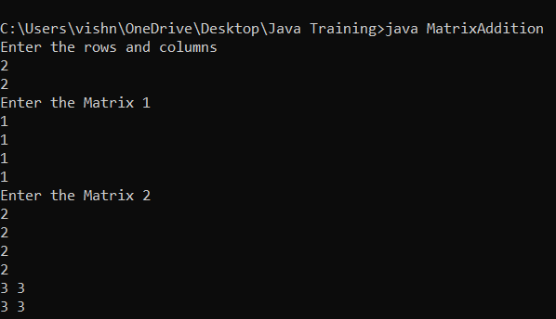

3. Write a program to search array element with Linear Search.

import java.util.Scanner;

public class LinearSearch

{

public static void main (String args[])

{

Scanner sc=new Scanner(System.in);

int a[]=new int[10];

System.out.println("Enter the numbers");

for(int i=0;i<10;i++)

{

a[i]=sc.nextInt();}

System.out.println("Enter the number you want to search");

int b=sc.nextInt();

int s = 0;

for(int i=0;i<10;i++)

{

if(a[i]==b)

{

System.out.println("The number is present and position is : " +(i+1));

s = 1;

break;

}

}

if(s==0)

{

System.out.println("The number is not present");

}

}}

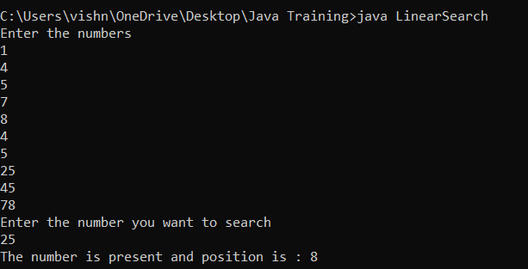

4. Write a program to sort array element with Bubble Sort.

import java.util.Scanner;

public class Bubblesort{

public static void main (String args[])

{

Scanner sc=new Scanner(System.in);

System.out.println("Enter the no of elements");

int n=sc.nextInt();

int a[]=new int[n];

int temp=0;

System.out.println("Enter the elements");

for(int i=0;i<n;i++)

{

a[i]=sc.nextInt();

}

for(int i=0;i<n-1;i++)

{for(int j=i+1;j<n-i-1;j++)

{

if(a[i]>a[j])

{temp=a[i];

a[i]=a[j];

a[j]=temp;}

}}

System.out.println("After Bubblesort :" );

for(int i=0;i<n;i++)

{

System.out.print(a[i]+" ");

}

}

}

